'Exercise 3-2-39 page 82
'Programmer: Samantha Naini
'Date: 2/6/2012
'Program Purpose: Compute the number of seconds between
'lightning and thunder in a storm when the distance is equivalent to the number of seconds divided by 5.
Option Explicit On
Option Strict On

Public Class frmThunderstorm

Private Sub btnCompute_Click(ByVal sender As System.Object, ByVal e As System.EventArgs) Handles btnCompute.Click
Dim distance As Double
distance = CDbl(txtNumSeconds.Text) / 5
distance = Math.Round(distance, 2)

txtAnswer.Text = "The distance of the storm is " & distance & " miles."
End Sub

End Class

Example 1: Example 2:

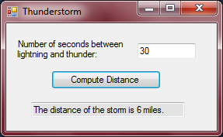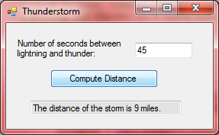

'Exercise 3-2-40 page 82
'Programmer: Samantha Naini
'Date: 2/6/2012
'Program Purpose: Compute your training heart rate using variables a as age and r as 'resting heart rate using the equation indicated in the code within variable “Beats”.
Option Explicit On
Option Strict On

Public Class frmTrainingHeartRate

Private Sub btnCompute_Click(ByVal sender As System.Object, ByVal e As System.EventArgs) Handles btnCompute.Click
Dim a, r, Beats As Double

a = CDbl(txtBoxAge.Text)
r = CDbl(txtBoxRHR.Text)

Beats = 0.7 * (220 - a) + 0.3 * r
Beats = Math.Round(Beats, 2)

txtBoxTHR.Text = "Your THR is " & Beats & " beats per minute."

End Sub

End Class

Example 1: Example 2:
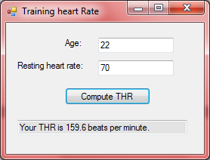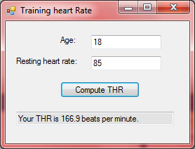

'Exercise 3-2-41 page 83
'Programmer: Samantha Naini
'Date: 2/6/2012
'Program Purpose: Compute the number of pounds lost through entering
'the number of hours spent cycling, running, and swimming in a program
'entitled "Triathlon".
Option Explicit On
Option Strict On

Public Class frmTriathlon

Private Sub btnCompute_Click(ByVal sender As System.Object, ByVal e As System.EventArgs) Handles btnCompute.Click
Dim cycling, running, swimming, weightloss As Double
cycling = CDbl(txtBoxCycling.Text) * 200
running = CDbl(txtBoxRunning.Text) * 475
swimming = CDbl(txtBoxSwimming.Text) * 275

weightloss = (cycling + running + swimming) / 3500
weightloss = Math.Round(weightloss, 1)

txtBoxWeightLoss.Text = weightloss & " pounds were lost."

End Sub
End Class

Example 1: Example 2:
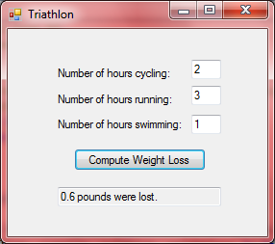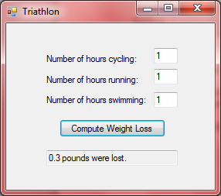
'Exercise 3-2-42 page 83
'Programmer: Samantha Naini
'Date: 2/6/2012
'Program Purpose: Compute the percentage of the baseball games won for a particular MLB team.

Option Explicit On
Option Strict On

Public Class frmBaseball

Private Sub btnCompute_Click(ByVal sender As System.Object, ByVal e As System.EventArgs) Handles btnCompute.Click
Dim gameswon, gameslost, percentage As Double
Dim team As String

gameswon = CDbl(txtWon.Text)
gameslost = CDbl(txtLost.Text)
team = CStr(txtTeam.Text)

percentage = gameswon / (gameswon + gameslost) * 100
percentage = Math.Round(percentage, 3)

txtPercentage.Text = "The " & team & " won " & percentage & " percent of their games. "

End Sub
End Class

Example 1: Example 2:
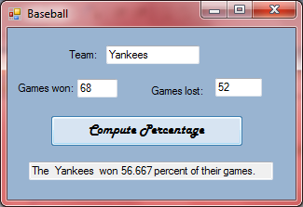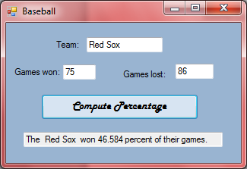

'Exercise 3-2-44 page 83
'Programmer: Samantha Naini
'Date: 2/6/2012
'Program Purpose: Request a company's earnings per share for the year and the price of
'one share of stock as input, and then display the company's price-to-earnings ratio (which is price/earnings).
Option Explicit On
Option Strict On

Public Class frmEPS

Private Sub btnCompute_Click(ByVal sender As System.Object, ByVal e As System.EventArgs) Handles btnCompute.Click
Dim ratio, share, earnings As Double

share = CDbl(txtPriceOfStock.Text)
earnings = CDbl(txtEarnings.Text)
ratio = CDbl(txtPriceOfStock.Text) / CDbl(txtEarnings.Text)
ratio = Math.Round(ratio, 3)

txtRatio.Text = "The company's earnings-per-share are " & ratio & " ."

End Sub

End Class
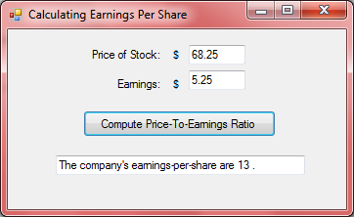
'Exercise 3-2-53 page 84
'Programmer: Samantha Naini
'Date: 2/6/2012
'Program Purpose: Calculate the average of a certain number of scores.

Option Strict On
Option Explicit On

Public Class fmAverageScore

Dim sum As Double 'sum of the scores entered
Dim num As Integer 'number of the scores entered

Private Sub btnRecord_Click(ByVal sender As System.Object, ByVal e As System.EventArgs) Handles btnRecord.Click
num += 1
sum += CDbl(txtScore.Text)
txtScore.Clear()
txtScore.Focus()
End Sub

Private Sub btnAverage_Click(ByVal sender As System.Object, ByVal e As System.EventArgs) Handles btnAverage.Click
txtAverage.Text = CStr(sum / num)
End Sub
End Class
